**GUIDELINES FOR POSTER PREPARATION**

Poster size: **A1 format (594 mm width x 841 mm height)**,

Orientation: **Portrait,**

Resolution: **min. 300dpi (both horizontal and vertical resolution)**

File format: **\*.tif (TIFF Image)**

File size: **max. 5 MB (on Email** [isae@agrif.bg.ac.rs](mailto:isae@agrif.bg.ac.rs) **)**

or

**max. 20 MB (via Google Drive link, WeTransfer link, or similar)**

Poster submission:

The poster must fit within these measurements.

* Please check in with the Registration Desk upon arrival. You will be told what your board

number assignment is and what session your poster has been linked with.

* Hang your poster only on the board that has been assigned to you. Poster boards will

be numbered so they can be found easily. Do not move numbers. (Please ask for

assistance if you need any help to hang your poster).

**Components of the poster:**

Posters should include a ISAE 2023 heading, title, names of authors and their addresses, abstract, introduction materials and methods, results and discussion, conclusions, acknowledgments (if any), references, tables and figures.

**ISAE 2023 Heading**

|  |  |  |
| --- | --- | --- |
| Grb_stit-NOVI Engl | The 6th International Symposium on Agricultural Engineering,  ISAE-2023  19th – 21st October 2023,  Belgrade – Zemun, Serbia | image4301  Logo |

**Title:**

Below the title should include the name(s) of the author(s) and their address(es).

**Abstract:**

The abstract should be a concise highlight of the results and conclusions and should be brief (<300 words).

**Introduction:**

The introduction should explain why the research was conducted and why it is important. The introduction should condense the relevant information in the field that led the author to do the research. The introduction is not a complete literature review, and only the most relevant references should be cited. The introduction should also contain a statement that describes the purpose or objective of the research.

**Materials and Methods:**

The section should briefly describe what was done so that the others can repeat the experiment. Experimental designs can be explained by use of figures if they will help clarify what was done. If the experiment was a complicated one with many sub-parts, subsections may be used to describe each sub-part.

**Results and discussion:**

This section describes the obtained results. Proper use of tables and figures can enhance and help explain the results. Statistical analysis of data is necessary, unless differences are so obvious that statistical analysis is superfluous. Although probability values of 0.05 and 0.01 are traditionally used, each author is free to choose his own level of significance.

**Conclusion:**

This section should be used to briefly offer a synopsis of the conclusions of the research data. Concisely state the main conclusion.

**Acknowledgments:**

This section should be used to thank organizations which supported the research monetarily and individuals who assisted in the research or preparation of the paper (optional).

**References:**

Select references with great care. Unless the paper is a review, there is no need to reference every paper written about a subject. Use only the most important ones.

**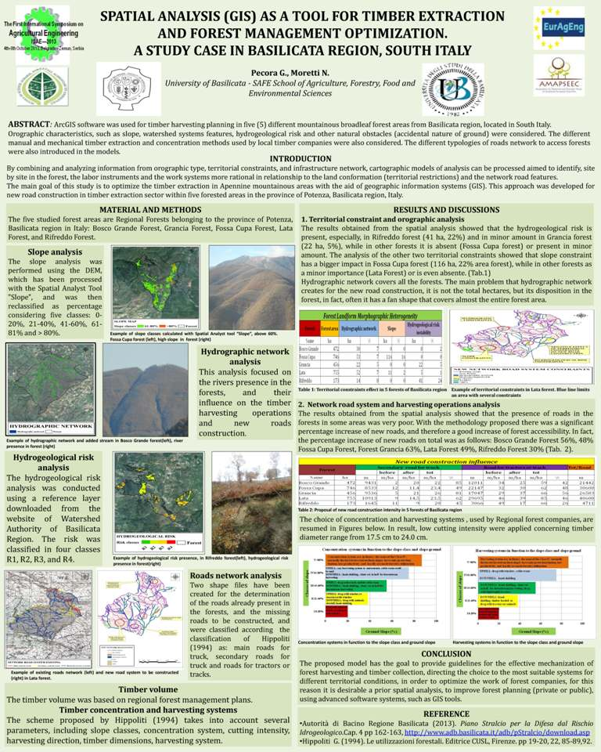**

**Electronic submission**. Poster(s) should be submitted to the Secretary of Symposium ISAE in electronic form (pdf) via the Internet, before the start of symposium. Please e-mail attached files (maximum size of message is up to 10 Mb) with Subject Header "Poster for ISAE” to: [isae@agrif.bg.ac.rs](mailto:isae@agrif.bg.ac.rs). Poster files should be designated in the following form: Djuric\_poster\_ISAE-20xx.pdf, where the name of the first author precedes the Symposium designation, ISAE.